Resistance Parameter – Ohm’s law
When a current flows in a material, the free electrons move through the material andcollide with other atoms. These collisions cause the electrons to lose some of theirenergy. This loss of energy per unit charge is the drop in potential across the material.The amount of energy lost by the electrons is related to the physical property ofthe material. These collisions restrict the movement of electrons. The property ofa material to restrict the flow of electrons is calledresistance, denoted by R. The symbol for the resistoris shown in Fig. 1.3.
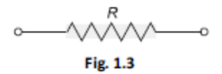
The unit of resistance is ohm (). Ohm isdefined as the resistance offered by the material when a current of one ampereflows between two terminals with one volt applied across it.According to Ohm’s law, the current is directly proportional to the voltage andinversely proportional to the total resistance of the circuit, i.e.I
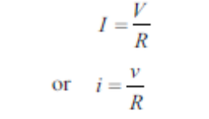
Inductance Parameter
A wire of certain length, when twisted into a coil becomes a basic inductor.If current is made to pass through an inductor, an electromagnetic field isformed. A change in the magnitude of the current changes the electromagneticfield. Increase in current expands the fields, and decrease in current reduces it.Therefore, a change in current produces change in the electromagnetic field,which

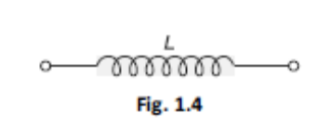
induces a voltage across the coil accordingto Faraday’s law of electromagnetic induction.The unit of inductance is henry, denoted by H.By definition, the inductance is one henry whencurrent through the coil, changing at the rate of oneampere per second, induces one volt across the coil.The symbol for inductance is shown in Fig. 1.4.The current-voltage relation is given by
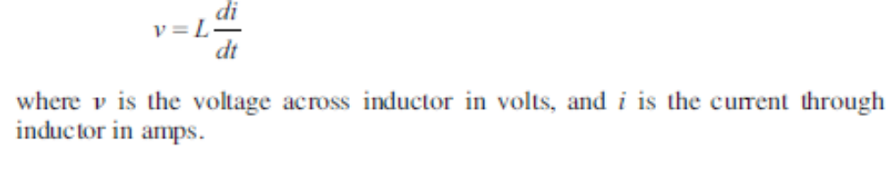
Capacitance Parameter
Any two conducting surfaces separated by an insulating medium exhibit theproperty of a capacitor. The conducting surfaces are called electrodes, and theinsulating medium is called dielectric. A capacitor stores energy in the form ofan electric field that is established by the opposite charges on the two electrodes.The electric field is represented by lines of force between the positive and negativecharges, and is concentrated within the dielectric. The amount of charge per unitvoltage that is capacitor can store is its capacitance, denoted by C. The unit ofcapacitance is Farad denoted by F. By definition,one Farad is the amount of capacitance when onecoulomb of charge is stored with one volt acrossthe plates. The symbol for capacitance is shown inFig. 1.5.
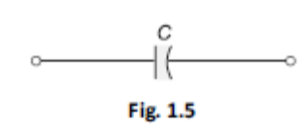
A capacitor is said to have greater capacitance if it can store more charge perunit voltage and the capacitance is given by
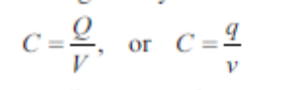

Kirchhoff’s Voltage Law
Kirchhoff’s voltage law states that the algebraic sum of all branch voltages aroundany closed path in a circuit is always zero at all instants of time. When the currentpasses through a resistor, there is a loss of energy and, therefore, a voltage drop.In any element, the current always flows from higher potential to lower potential.Consider the circuit in Fig. 1.50. It is customary to take the direction of current I asindicated in the figure, i.e. it leaves the positive terminal of the voltage source andenters into the negative terminal.Fig. 1.50
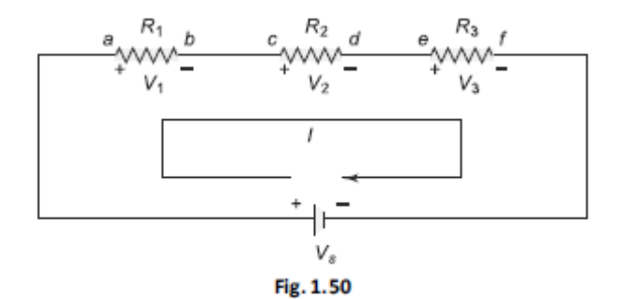

As the current passes through the circuit, the sum of the voltage drop aroundthe loop is equal to the total voltage in that loop. Here the polarities are attributedto the resistors to indicate that the voltages at points a, c and e are more than thevoltages at b, d and f, respectively, as the current passes from a to f.
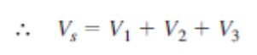
Kirchhoff’s Current Law
Kirchhoff’s current law states that the sum of the currents entering into any node isequal to the sum of the currents leaving that node. The node may be an interconnection of two or more branches. In any parallel circuit, the node is a junction point of two or more branches. The total current entering into a node is equal to the current leaving that node. For example, consider the circuit shown in Fig. 1.67, which contains two nodes A and B. The total current IT entering node A is divided into I1, I2 and I3. These currents flow out of node A. According to Kirchhoff’s current law,

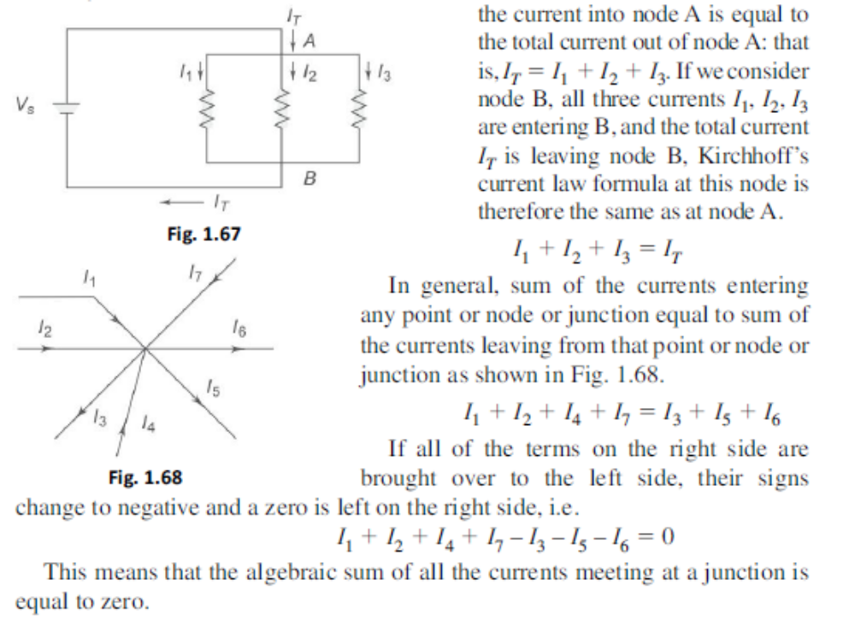

Power In Series Circuit
The total power supplied by the source in any series resistive circuit is equal tothe sum of the powers in each resistor in series, i.e.PS = P1 + P2 + P3 + … +Pm
where m is the number of resistors in series, PS is the total power supplied bysource and Pm is the power in the last resistor in series. The total power in theseries circuit is the total voltage applied to a circuit, multiplied by the totalcurrent. Expressed mathematically,

Power in a Parallel Circuit
The total power supplied by the source in any parallel resistive circuit is equal tothe sum of the powers in each resistor in parallel, i.e.
PS = P1 + P2 + P3 + … +Pmwhere
where m is the number of resistors in parallel, PS is the total power and Pm isthe power in the last resistor.

THE STAR-DELTA TRANSFORMATION
In the preceding chapter, a simple technique called the source transformationtechnique has been discussed. The star delta transformation is another techniqueuseful in solving complex networks. Basically, any three circuit elements, i.e.resistive, inductive or capacitive, may be connected in two different ways.One way of connecting these elements is called the star connection, or the Yconnection. The other way of connecting these elements is called the delta (D)connection. The circuit is said to be in star connection, if three elements areconnected as shown in Fig. 1.126(a), when it appears like a star (Y). Similarly,the circuit is said to be in delta connection, if three elements are connected asshown in Fig. 1.126(b), when it appears like a delta (D).
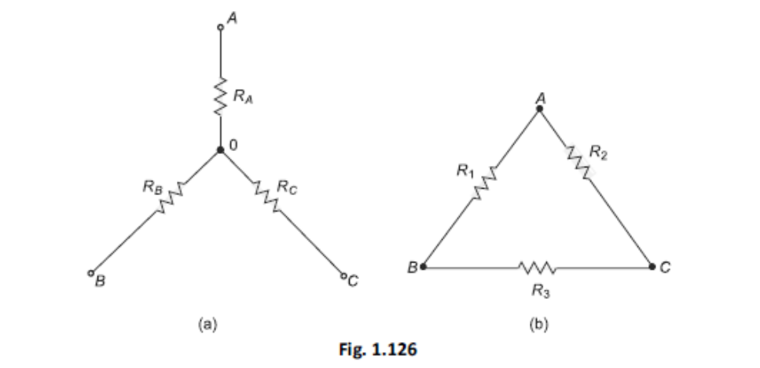
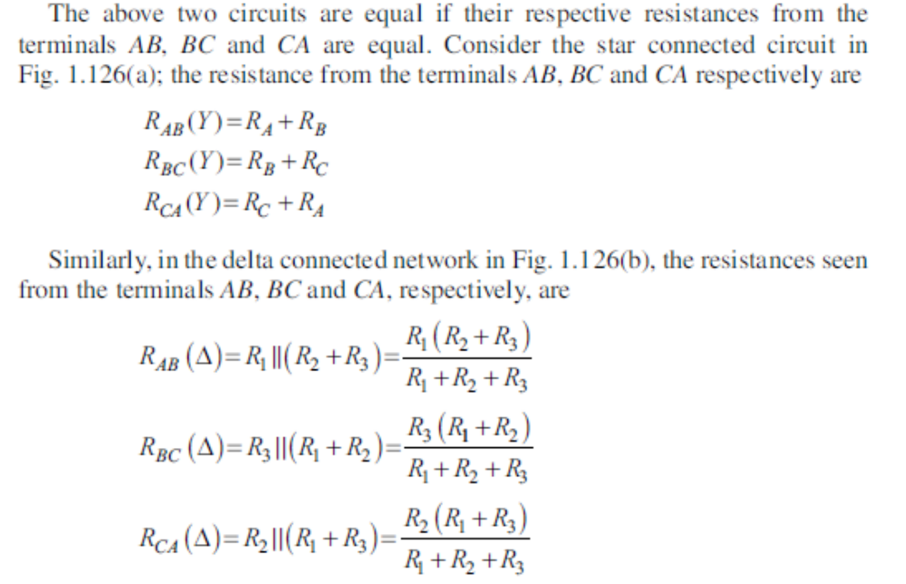
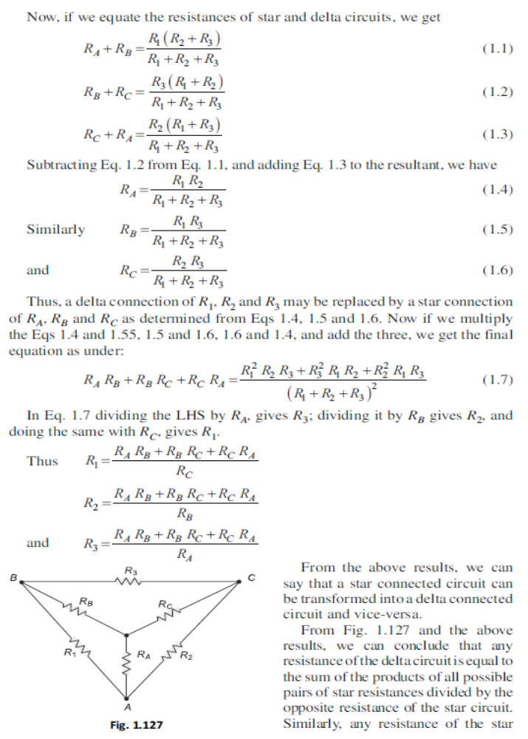
PERIODIC WAVEFORMS (DETERMINATION ON RMS,
AVERAGE VALUE AND FORM FACTOR
Many a time, alternating voltages and currents are represented by a sinusoidal wave, or simply a sinusoid. It is a very common type of alternating current (ac) and alternating voltage. The sinusoidal wave is generally referred to as a sine wave. Basically an alternating voltage (current) waveform is defined as the voltage (current) that fluctuates with time periodically, with change in polarity and direction. In general, the sine wave is more useful than other waveforms, like pulse, sawtooth, square, etc. There are a number of reasons for this. One of the reasons is that if we take any second order system, the response of this system is a sinusoid. Secondly, any periodic waveform can be written in terms of sinusoidal function according to Fourier theorem. Another reason is that its derivatives and integrals are also sinusoids. A sinusoidal function is easy to analyse. Lastly, the sinusoidal function is easy to generate, and it is more useful in the power industry. The shape of a sinusoidal waveform is shown in Fig. 2.1. The waveform may be either a current waveform, or a voltage waveform. As seen from the Fig. 2.1, the wave changes its magnitude and direction with time. If we start at time t 5 0, the wave goes to a maximum value and returns to zero, and then decreases to a negative maximum value before returning to zero. The sine wave changes with time in an orderly manner. During the positive portion
of voltage, the current flows in one direction; and during the negativeportion of voltage, the current flows in the opposite direction.

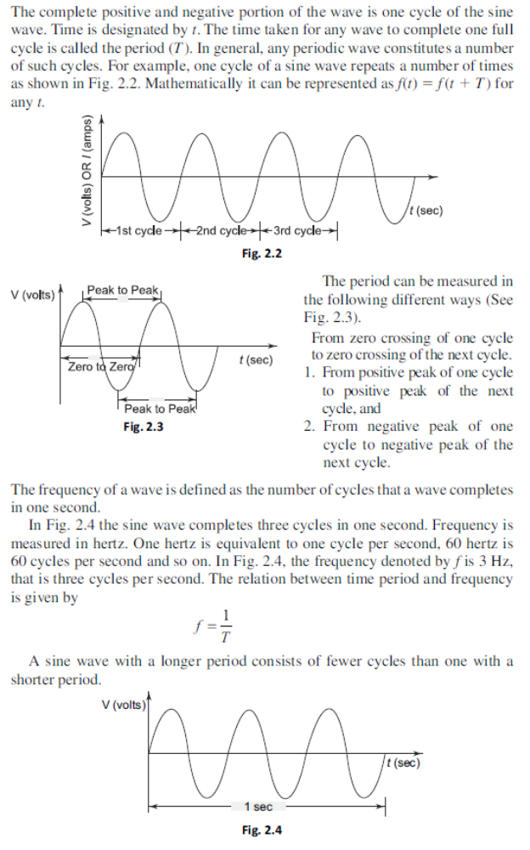
Angular Relation of a Sinusoidal Wave
A sine wave can be measured along the X-axis on a time base which is frequency- dependent. A sine wave can also be expressed in terms of an angular measurement. This angular measurement is expressed in degrees or radians. A radian is defined as the angular distance measured along the circumference of a circle which is equal to the radius of the circle. One radian is equal to 57.3°. In a 360° revolution, there are 2p radians. The angular measurement of a sine wave is based on 360° or 2p radians for a complete cycle as shown in Figs 2.6 (a) and (b). 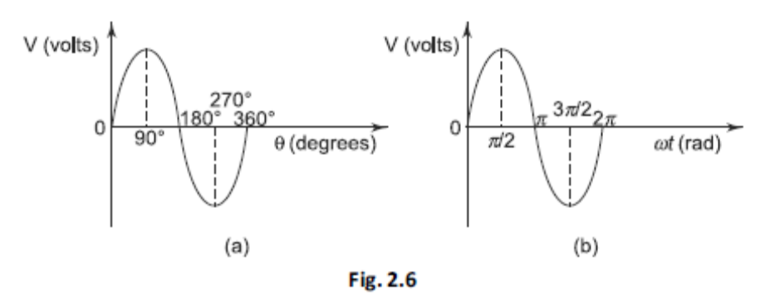
Phase of a Sinusoidal Wave
The phase of a sine wave is an angular measurement that specifies the position of the sine wave relative to a reference. The wave shown in Fig. 2.7 is taken as the reference wave. When the sine wave is shifted left or right with reference to the wave shown in Fig. 2.7, there occurs a phase shift. Figure 2.8 shows the phase shifts of a sine wave. In Fig. 2.8(a), the sine wave is shifted to the right by 90° (p/2 rad) shown by the dotted lines. There is a phase angle of 90° between A and B. Here the waveform B is lagging behind waveform A by 90°. In other words, the sine wave A is leading the waveform B by 90°. In Fig. 2.8(b) the sine wave A is lagging behind the waveform B by 90°. In both cases, the phase difference is 90°.
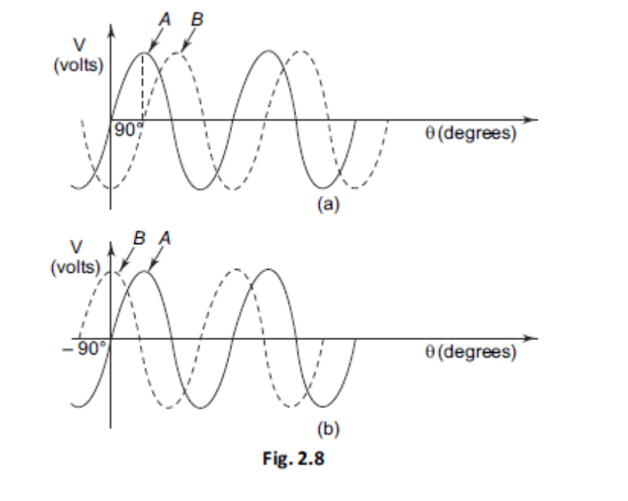
The Sinusoidal Wave Equation
A sine wave is graphically represented as shown in Fig. 2.12(a). The amplitude of a sine wave is represented on vertical axis. The angular measurement (in degrees or radians) is represented on horizontal axis. Amplitude A is the maximum value of the voltage or current on the Y-axis. In general, the sine wave is represented by the equation v(t) = Vm sin wt

Instantaneous Value
Consider the sine wave shown in Fig. 2.14. At any given time, it has some instantaneous value. This value is different at different points along the waveform. In Fig. 2.14 during the positive cycle, the instantaneous values are positive and during the negative cycle, the instantaneous values are negative. In Fig. 2.14 shown at time 1 ms, the value is 4.2 V; the value is 10 V at 2.5 ms, – 2 V at 6 ms and – 10 V at 7.5 and so on.
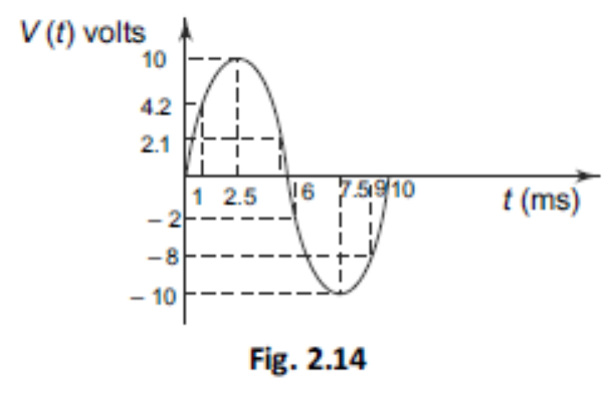

Peak Value
The peak value of the sine wave is the maximum value of the wave during Fig. 2.14 positive half cycle, or maximum value
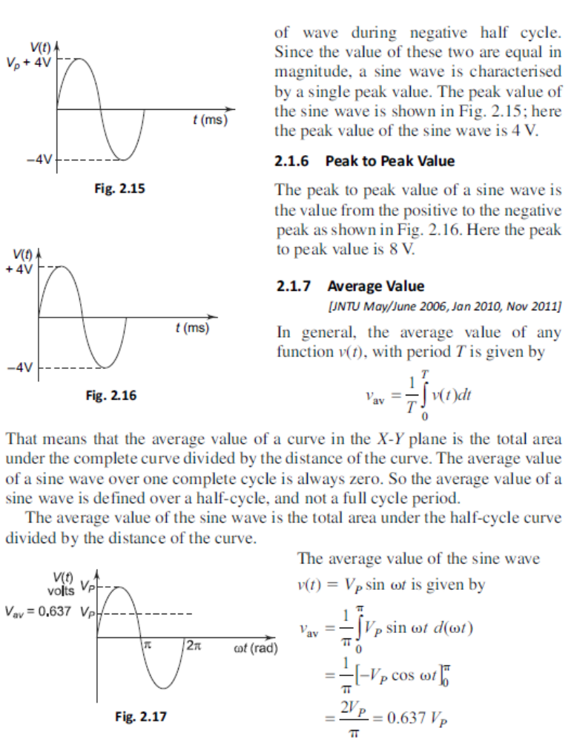
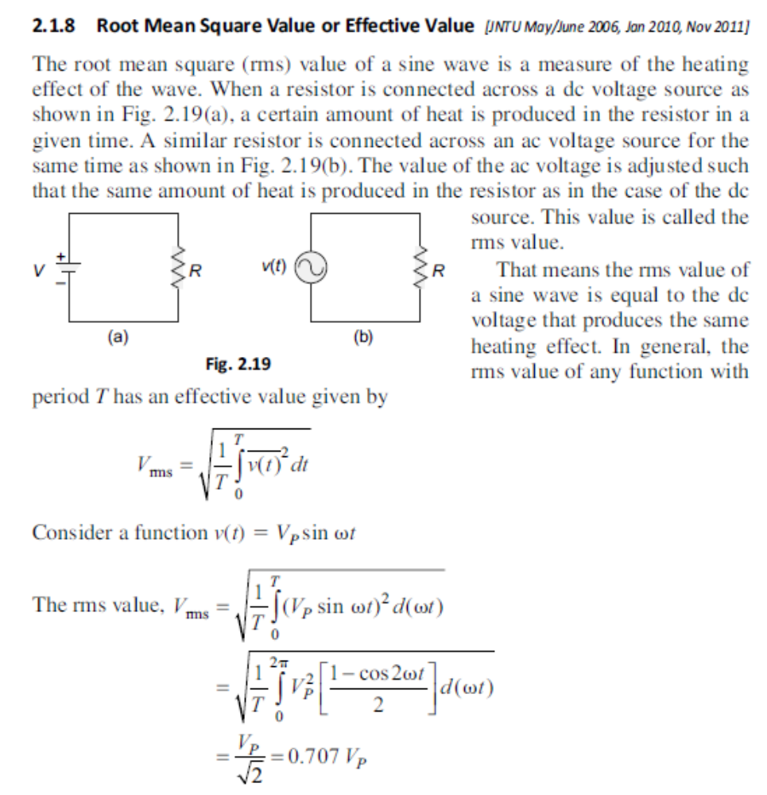
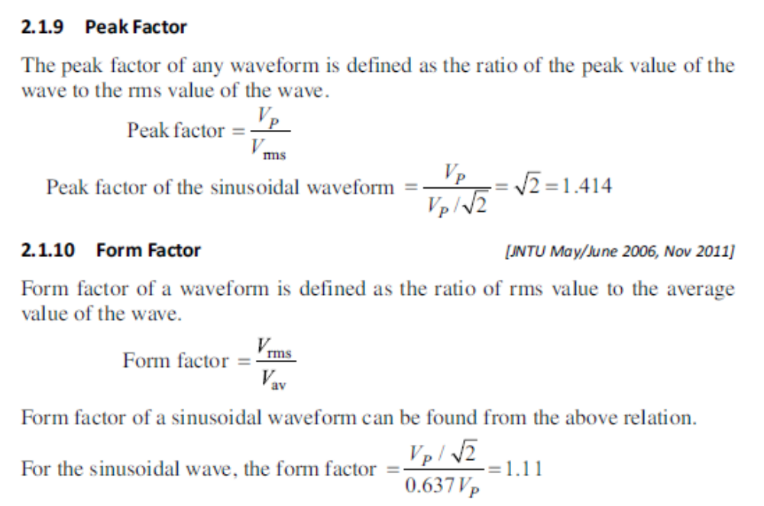
Instantaneous Power
In a purely resistive circuit, all the energy delivered by the source is dissipated in the form of heat by the resistance. In a purely reactive(inductive or capacitive) circuit, all the energy delivered by the source is stored by the inductor or capacitor in its magnetic or electric field during a portion of the voltage cycle, and then is returned to the source during another portion of the cycle, so that no net energy is transferred. When there is complex impedance in a circuit, part of the energy is alternately stored and returned by
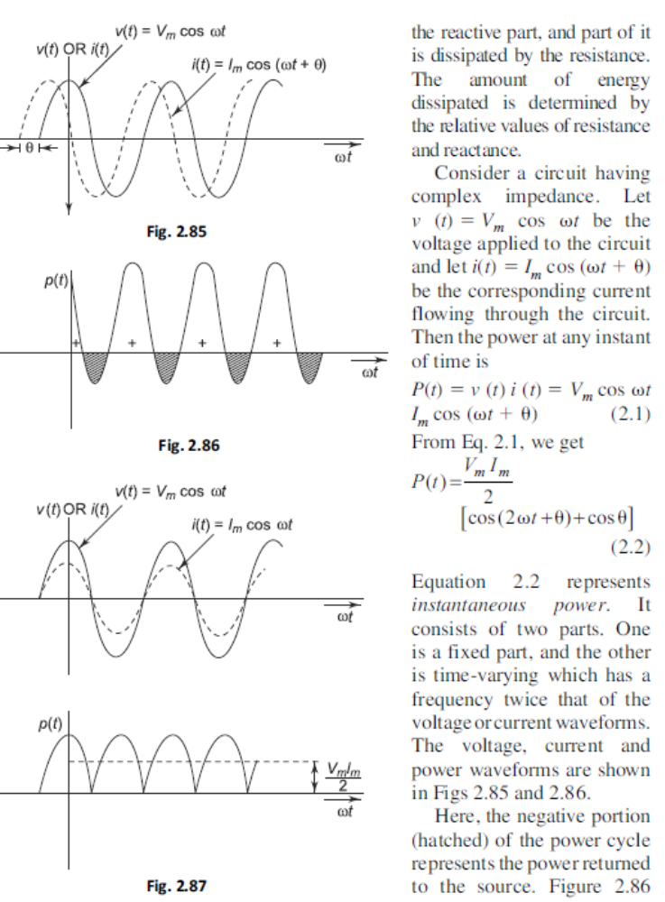
shows that the instantaneous power is negative whenever the voltage and current are of opposite sign. In Fig. 2.86, the positive portion of the power is greater than the negative portion of the power; hence the average power is always positive, which is almost equal to the constant part of the instantaneous power (Eq. 2.2). The positive portion of the power cycle varies with the phase angle between the voltage and current waveforms. If the circuit is pure resistive, the phase angle between voltage and current is zero; then there is no negative cycle in the P(t) curve. Hence, all the power delivered by the source is completely dissipated in the resistance.
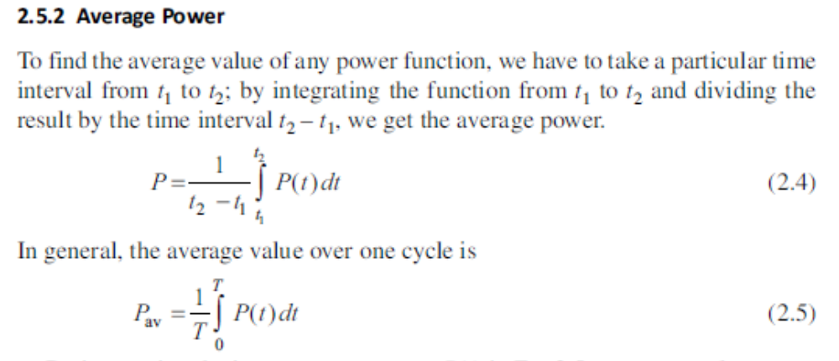
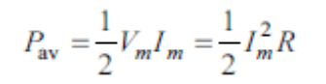
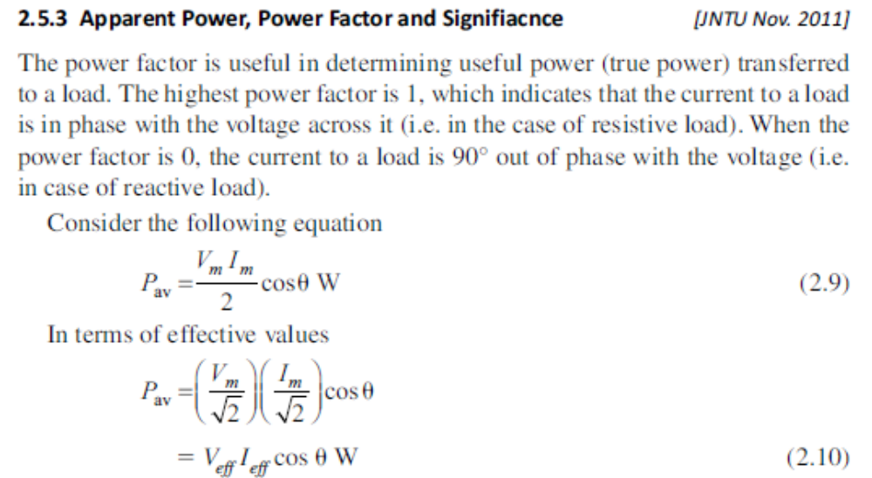
The average power is expressed in watts. It means the useful power transferred from the source to the load, which is also called true power. If we consider a dc source applied to the network, true power is given by the product of the voltage and the current. In case of sinusoidal voltage applied to the circuit, the product of voltage and current is not the true power or average power. This product is called apparent power. The apparent power is expressed in volt amperes, or simply VA.
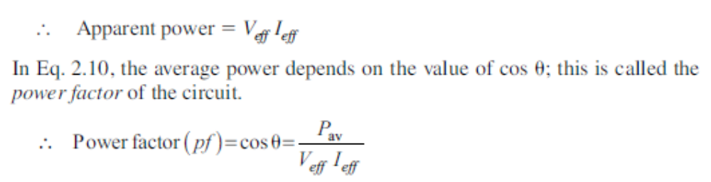
Therefore, power factor is defined as the ratio of average power to the apparent power, whereas apparent power is the product of the effective values of the current and the voltage. Power factor is also defined as the factor with which the volt amperes are to be multiplied to get true power in the circuit. In the case of sinusoidal sources, the power factor is the cosine of the phase angle between voltage and current
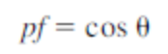
As the phase angle between voltage and total current increases, the power factor decreases. The smaller the power factor, the smaller the power dissipation. The power factor varies from 0 to 1. For purely resistive circuits, the phase angle between voltage and current is zero, and hence the power factor is unity. For purely reactive circuits, the phase angle between voltage and current is 90°, and hence the power factor is zero. In an RC circuit, the power factor is referred to as leading power factor because the current leads the voltage. In an RL circuit, the power factor is referred to as lagging power factor because the current lags behind the voltage.
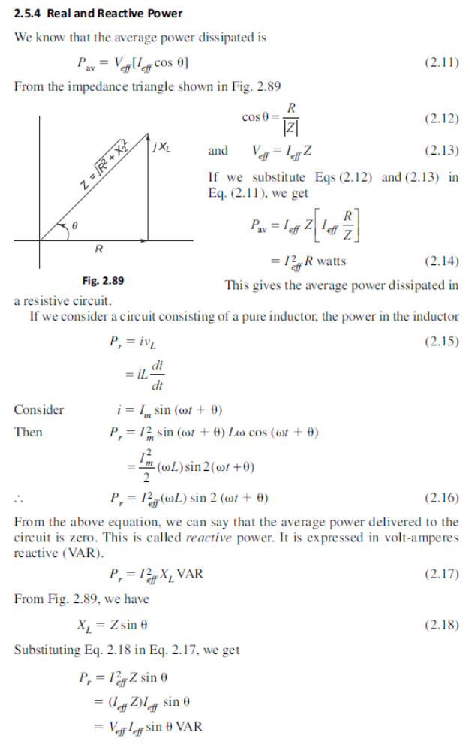
Superposition Theorem (dc Excitation)
The superposition theorem states that in any linear network containing two or more sources, the response in any element is equal to the algebraic sum of the responses caused by individual sources acting alone, while the other sources are non-operative; that is, while considering the effect of individual sources, other ideal voltage sources and ideal current sources in the network are replaced by short circuit and open circuit across their terminals. This theorem is valid only for linear systems. This theorem can be better understood with a numerical example. Consider the circuit which contains two sources as shown in Fig. 6.1.
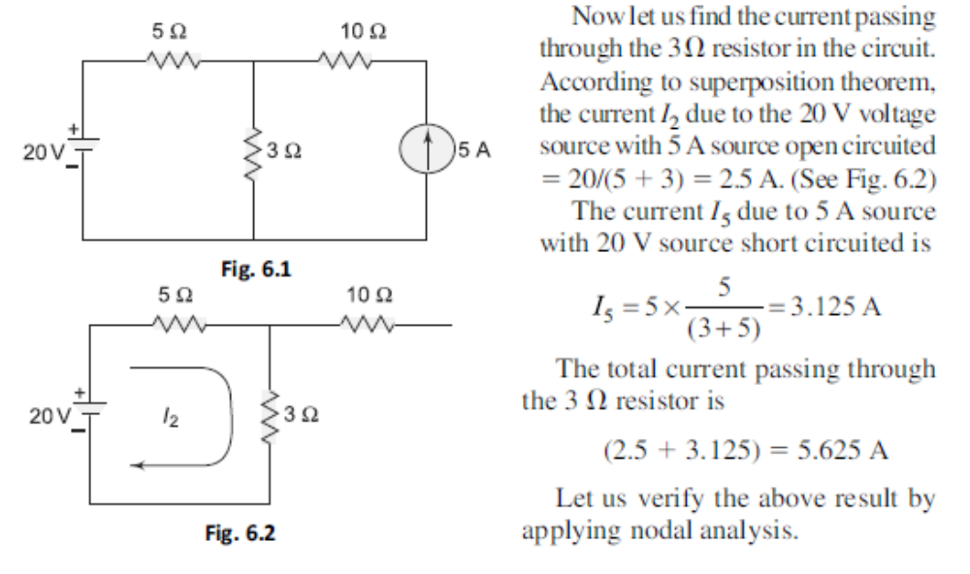
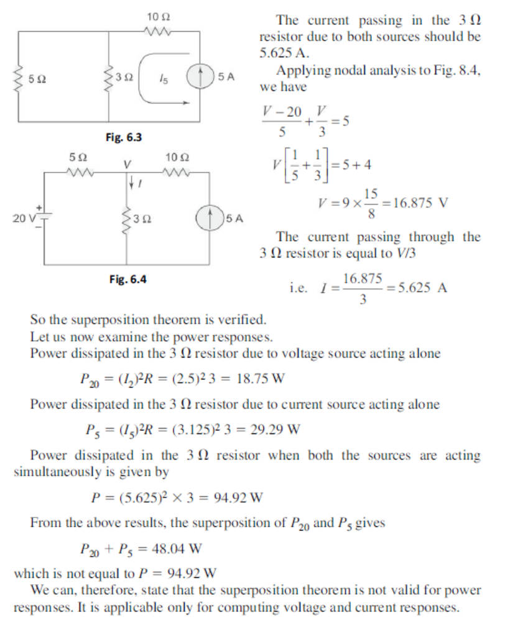

Thevenin’s Theorem (dc Excitation)
In many practical applications, it is always not necessary to analyse the complete circuit; it requires that the voltage, current, or power in only one resistance of a circuit be found. The use of this theorem provides a simple, equivalent circuit which can be substituted for the original network. Thevenin’s theorem states that any two terminal linear network having a number of voltage current sources and resistances can be replaced by a simple equivalent circuit consisting of a single voltage source in series with a resistance, where the value of the voltage source is equal to the open circuit voltage across the two terminals of the network, and resistance is equal to the equivalent resistance measured between the terminals with all the energy sources are replaced by their internal resistances. According to Thevenin’s theorem, an equivalent circuit can be found to replace the circuit in Fig. 6.47.

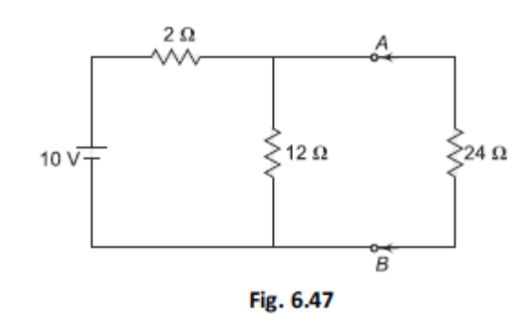

In the circuit, if the load resistance 24 V is connected to Thevenin’s equivalent circuit, it will have the same current through it and the same voltage across its terminals as it experienced in the original circuit. To verify this, let us find the current passing through the 24 V resistance due to the original circuit.
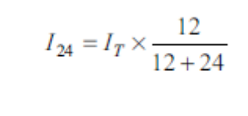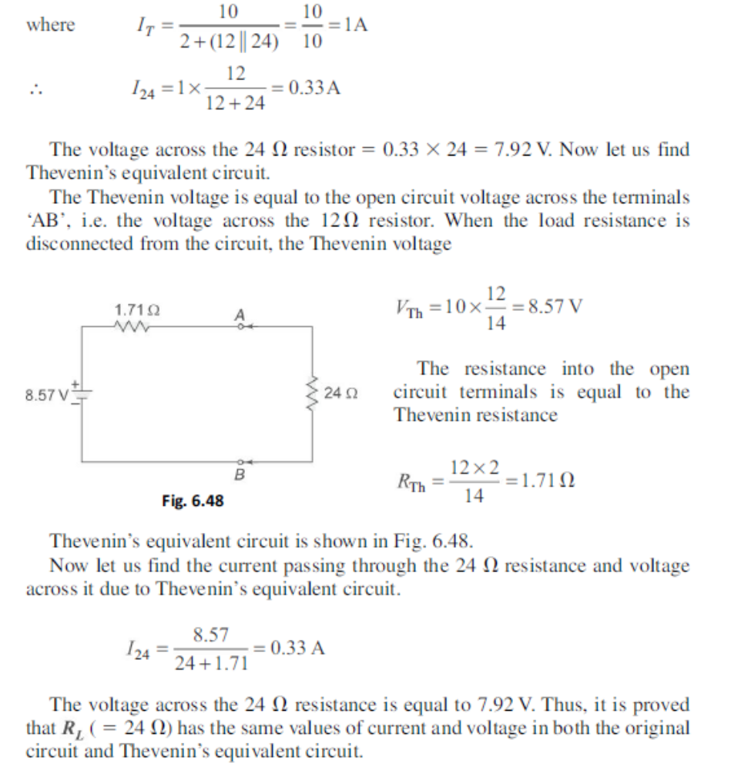
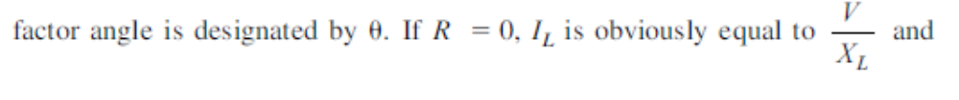

SERIES RESONANCE
Frequency response analysis is important to us for two primary reasons. First, if we know the frequency response then we can predict the response of the circuit to any input. Sinusoidal waveforms have the elegent property that they can be combined to form other (non-sinusoidal) waveforms. Therefore the frequency response allows us to understand a circuits response to more complex inputs. Second, we are often interested in designing circuits with particular frequency characteristics. For example, in the design of an audio 3-way loud speaker system, we would like to direct low frequency signals to the woofers, high frequency signals to the tweets, and mid frequency signals to the mid range speakers. Therefore we would need a circuit that is capable of passing certain frequencies of a signal and rejecting others. The concept of resonance is highly useful in the design of basic filtering circuits for use in everyday applications such as an audio amplifiers. Consider an AC circuit with a single voltage source and any number of resistors, capacitors and inductors. If the frequency of the source is fixed, then a complete analysis in either the time domain or the frequency domain is possible. In the time domain, a differential is extracted from the circuit and solved. In general, the order of the differential equation is equal to the number of energy storage elements in the circuit. A much easier method is to solve the circuit using phasor analysis in the frequency domain. The analysis is easier in the frequency domain because differentiation in time transforms to multiplication by jv. As a result, an algebraic equation arises rather than a differential equation. Algebraic equations are easier to solve the differential equations. If the frequency of the voltage source is varied, the impedance of each storage element changes, as the response of the circuit varies as a function of input frequency. The frequency response of a circuit is a quantitative description of its behaviour in the frequency domain. In many electrical circuits, resonance is a very important phenomenon. The study of resonance is very useful, particularly in the area of communications. For example, the ability of a radio receiver to select a certain frequency, transmitted by a station and to eliminate frequencies from other stations is based on the principle of resonance. In a series RLC circuit, the current lags behind, or leads the applied voltage depending upon the values of XLand XC  XL causes the total current to lag behind the applied voltage, while XC causes the total current to lead the applied voltage. When XL . XC, the circuit is predominantly inductive, and when XC . XL the circuit is
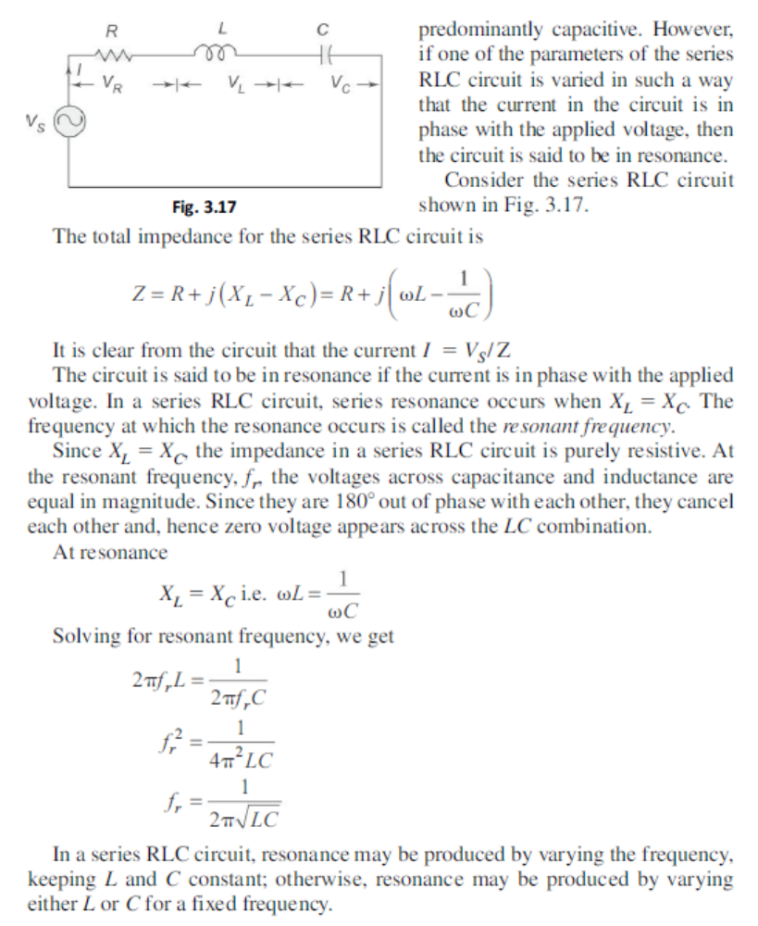

BANDWIDTH OF AN RLC CIRCUIT
The bandwidth of any system is the range of frequencies for which the current or output voltage is equal to 70.7% of its value at the resonant frequency, and it is denoted by BW. Figure 3.26 shows the response of a series RLC circuit.

